YUVA INTERN TASK 4
DATA SCIENCE TOOL MASTERY PROJECT
HR ANALYTICS AND EMPLOYEE ATTRITION ANALYSIS USING
PYTHON
A Detailed Practical Project Report
Dataset: HR_Analytics.csv
Records: 1480 | Columns: 38
Tools: Python, Pandas, NumPy, Matplotlib, Seaborn and Jupyter Notebook
Prepared for: Data Science Tool Mastery Project Submission
Report date: 30 October 2026
Important note: This report describes the supplied dataset. It does not prove that any factor causes attrition.

Table of Contents
- 1. Executive Summary
- 2. Introduction
- 3. Background and Business Problem
- 4. Project Aim and Objectives
- 5. Scope of the Project
- 6. Dataset Overview
- 7. Data Dictionary
- 8. Tools and Technologies
- 9. Project Methodology
- 10. Data Loading and Initial Inspection
- 11. Data Quality Assessment
- 12. Data Cleaning and Preparation
- 13. Exploratory Data Analysis
- 14. Overall Attrition Analysis
- 15. Department Analysis
- 16. Job Role Analysis
- 17. Overtime Analysis
- 18. Age Group Analysis
- 19. Salary Slab Analysis
- 20. Marital Status Analysis
- 21. Business Travel Analysis
- 22. Visualization and Interpretation
- 23. Key Findings
- 24. HR Recommendations
- 25. Fairness, Privacy and Ethics
- 26. Limitations
- 27. Testing and Validation
- 28. Learning Outcomes
- 29. Conclusion and Future Scope
- 30. Appendix: Reproducible Code
- 31. GitHub Portfolio Checklist
- 32. References

1. Executive Summary
This project demonstrates a practical data science workflow using the supplied HR_Analytics.csv file. The dataset contains 1,480 records and 38 columns. Within these records, 238 are marked Attrition = Yes and 1,242 are marked Attrition = No. The overall recorded attrition rate is 16.08%. The project uses Python to inspect, prepare, summarize and visualize employee data, with Pandas as the main data manipulation library, NumPy for numerical support, and Matplotlib/Seaborn for charts.
The analysis compares attrition rates across departments, job roles, overtime groups, age groups, salary slabs, marital-status groups and business-travel categories where those fields are available. The results identify patterns that may guide further HR investigation. For example, the overtime group has a higher observed attrition rate than the non-overtime group in this dataset. Such a difference is an association, not proof that overtime alone causes employees to leave.
The report also discusses data-quality checks, missing values, duplicate records, category-label inconsistencies, privacy, fairness and limitations. The purpose is not to make decisions about individual employees, but to demonstrate how data can be examined responsibly and converted into useful questions. The final deliverables should include this Word report and a working Jupyter Notebook with matching code and outputs.

2. Introduction
Data science is the process of using data, programming, statistics and visualization to understand a problem and communicate evidence. Organizations collect data about their operations, customers, products and employees. When data is organized and analyzed carefully, it can help identify patterns that would be difficult to see by looking at individual records.
Human Resources (HR) analytics applies these methods to workforce questions. One important question is employee attrition: the recorded departure of employees from an organization. Attrition may be associated with many overlapping factors, such as job role, work schedule, compensation, career opportunities, management practices, personal circumstances and the overall labor market. A dataset can show where rates differ, but it usually cannot explain every reason behind an employee's decision.
This project uses a supplied HR dataset as a learning exercise for the Data Science Tool Mastery Project. It combines code, data checks, calculations, charts and written interpretation. The report is written as a detailed document rather than a slide presentation so that the workflow and findings can be explained fully.

3. Background and Business Problem
Employee turnover can create direct and indirect costs. Recruiting a replacement may require advertising, screening and interviewing. A new employee may also need training before becoming fully productive. When experienced staff leave, teams can lose knowledge, customer relationships and continuity. However, a low attrition rate is not automatically ideal in every situation: some employee movement is expected and can create opportunities for new skills. The useful question is whether observed patterns indicate areas where the organization should investigate employee experience and working conditions.
Business problem: HR teams need a clear, evidence-based view of recorded attrition patterns across employee groups. Without structured analysis, a team may rely on assumptions or raw counts that do not account for different group sizes. This project calculates group-level rates and uses visualizations to make comparisons easier.
Analytical questions include: What proportion of records have Attrition = Yes? How do rates vary by department and job role? Is the rate different for employees marked as working overtime? How do age, salary and marital-status groups compare? What quality issues might influence interpretation? Which practical, fair actions could HR investigate?

4. Project Aim and Objectives

4.1 Aim
To demonstrate practical use of core data science tools by analyzing employee attrition patterns in a structured CSV dataset and communicating findings in a clear, responsible report.

4.2 Objectives
- Load the CSV dataset into a Pandas DataFrame and verify its dimensions.
- Inspect column names, data types, sample rows and basic statistics.
- Identify missing values, exact duplicate records and inconsistent category labels.
- Calculate the overall attrition rate using a transparent formula.
- Compare attrition rates across departments, job roles, overtime, age, salary and marital-status categories.
- Create readable charts that communicate group-level patterns.
- Explain the findings without claiming causation that the analysis cannot establish.
- Recommend fair, practical follow-up investigations and document the limitations of the dataset.

5. Scope of the Project
The project focuses on descriptive analytics. It summarizes the records provided and compares categories in the available columns. It does not build a predictive machine-learning model, make individual-level predictions, or determine the true reason why any employee left. The project also does not assume that the supplied dataset represents every organization or workforce.
- Included: CSV loading, inspection, quality checks, descriptive statistics, group comparisons, visualizations and reporting.
- Included: examples of Python code using Pandas, NumPy, Matplotlib and Seaborn.
- Not included: causal inference, a validated predictive model, employee-level risk scoring or automated HR decisions.
- Not included: confirmation of the original dataset's publisher or representativeness unless separately verified.

6. Dataset Overview
The supplied CSV has 1,480 rows and 38 columns. Each row is treated as one employee record for the purpose of this analysis. The columns include employee characteristics, work-related attributes, satisfaction ratings and an Attrition field with Yes/No values. The data includes categorical variables and numerical variables, which require different methods of inspection.
Dataset property | Observed value
File name provided | HR_Analytics(1).csv (use the exact local filename in code)
Rows / records | 1480
Columns / features | 38
Attrition = Yes | 238
Attrition = No | 1242
Overall attrition rate | 16.08%
Missing cells in source file | 57
Exact duplicate rows | 7

The dataset should be treated as supplied learning data. If the original source, collection period or intended use is not documented, that uncertainty should be stated rather than guessed.

7. Data Dictionary
Field | Type | Meaning | Use in project
Attrition | Categorical | Whether the record is marked Yes or No for attrition. | Main outcome for this report.
Department | Categorical | Department or business unit. | Compare department-level rates.
JobRole | Categorical | Employee job role. | Compare role-level rates.
OverTime | Categorical | Whether overtime is recorded as Yes or No. | Compare overtime groups.
Age / AgeGroup | Numeric / categorical | Age or grouped age band. | Compare age groups where available.
SalarySlab | Categorical | Grouped salary band. | Compare salary bands.
MaritalStatus | Categorical | Recorded marital-status group. | Descriptive comparison only; sensitive context.
BusinessTravel | Categorical | Recorded travel frequency category. | Check category-label consistency.
MonthlyIncome | Numeric | Monthly income value. | Can support further descriptive analysis.
YearsAtCompany | Numeric | Recorded tenure at the company. | Can support tenure analysis.
YearsWithCurrManager | Numeric | Years with current manager. | Missing values require care.
JobSatisfaction | Ordinal | Recorded job satisfaction rating. | Ordinal ratings should not automatically be treated as continuous measurements.
WorkLifeBalance | Ordinal | Recorded work-life balance rating. | Can support further group comparisons.

8. Tools and Technologies
Tool | Purpose
Python | Core language used to write and run the analysis.
Pandas | Reads CSV data, inspects columns, handles missing values, groups records and calculates summaries.
NumPy | Supports numerical operations and array-based calculations.
Matplotlib | Creates bar charts and other basic visualizations.
Seaborn | Provides statistical plotting functions and works with Pandas DataFrames.
Jupyter Notebook | Keeps code cells, results and explanations together in a reproducible document.
VS Code | Editor in which the notebook can be opened and executed.
Microsoft Word | Used to prepare the required .docx report.
GitHub | Can host the notebook, README and other shareable project files.

Using multiple tools in one workflow demonstrates that data analysis is not only writing code. It includes understanding the dataset, checking its quality, calculating measures, presenting evidence and explaining what the results mean.

9. Project Methodology

Step 1: Define the question
Specify the outcome being studied (recorded attrition) and the groups to compare.

Step 2: Load the dataset
Read the CSV file into Pandas and verify that the file path is correct.

Step 3: Inspect the data
Review dimensions, column names, types, sample rows and category values.

Step 4: Audit data quality
Count missing cells and duplicate rows; inspect unusual category labels.

Step 5: Prepare the analysis fields
Standardize only confirmed label variations and document every change.

Step 6: Calculate rates
For each group, divide records marked Yes by the total records in that group and multiply by 100.

Step 7: Visualize
Use bar charts with titles and labelled axes to compare the calculated rates.

Step 8: Interpret
Describe the patterns and consider group size, missingness and alternative explanations.

Step 9: Recommend next steps
Suggest fair investigations rather than using descriptive findings to make individual decisions.

Step 10: Document and validate
Save code and outputs, run cells from top to bottom, and ensure the report matches the final results.

10. Data Loading and Initial Inspection
The first stage confirms that the file is readable and the analysis is using the intended dataset. If the notebook and CSV are in the same folder, the filename alone can be used. Otherwise, provide the correct file path.
import pandas as pd
import numpy as np
import matplotlib.pyplot as plt
import seaborn as sns
df = pd.read_csv("HR_Analytics(1).csv")
print("Dataset shape:", df.shape)
display(df.head())
display(df.sample(5, random_state=42))
The shape output should show the number of rows and columns. head() displays the first records; sample() shows a small reproducible sample. A reproducible random_state helps the same sample appear when the code is run again.
print(df.columns.tolist())
df.info()
display(df.describe(include="all").T)
Column names and data types help determine which calculations are appropriate. describe(include='all') summarizes numerical and categorical columns. Some fields, such as satisfaction ratings, are ordinal categories and need careful interpretation.

11. Data Quality Assessment
The initial quality check found 57 missing cells across the dataset and 7 exact duplicate rows. The largest missing-value count is in the YearsWithCurrManager field. Missing values should be examined in context; a blank value does not necessarily mean zero years. Duplicate rows should also be checked against available employee identifiers and the dataset's documentation before deletion.

11.1 Missing values
missing = df.isna().sum().sort_values(ascending=False)
print(missing[missing > 0])
This code lists columns with missing values. A suitable treatment depends on the field and the analysis. If a report does not use a column, missing values in that column may not affect a particular calculation. If it does use the column, the report should state whether records were excluded, imputed or otherwise handled.

11.2 Duplicate records
print("Exact duplicate rows:", df.duplicated().sum())
# Review duplicates before taking any action.
duplicates = df[df.duplicated(keep=False)]
display(duplicates.head(10))
Exact duplicate rows may reflect accidental duplication, but removal should not be automatic. Confirm the data source and unique employee identifiers before deleting records. Keep an unchanged copy of the original data.

11.3 Category inconsistencies
for col in df.select_dtypes(include="object").columns:
print("\\n", col)
print(df[col].value_counts(dropna=False).head(20))
Category counts can reveal differences in spacing, capitalization or spelling. For example, 'TravelRarely' and 'Travel_Rarely' may represent the same category, but the analyst should confirm that interpretation before combining them.

11.4 Data quality summary
Issue | Observed evidence | Recommended action
Missing values | 57 missing cells overall | Review affected fields and document the handling method.
Exact duplicates | 7 exact duplicate rows | Check identifiers and source before removing any rows.
Category labels | At least one travel-label variation was identified in inspection. | Standardize confirmed equivalents and preserve a note of the change.
Source metadata | Source and time period are not confirmed by the CSV alone. | Record the provider, date and definitions if available.

12. Data Cleaning and Preparation
Cleaning makes comparisons more reliable. The original DataFrame should be preserved, and transformations should be performed in a separate working copy so the source is not overwritten.
work = df.copy()
# Remove leading/trailing spaces from text fields
for col in work.select_dtypes(include="object").columns:
work[col] = work[col].str.strip()
# Standardize a confirmed equivalent label for analysis only
if "BusinessTravel" in work.columns:
work["BusinessTravel"] = work["BusinessTravel"].replace(
{"TravelRarely": "Travel_Rarely"}
)
# Check the outcome categories
print(work["Attrition"].value_counts(dropna=False))
The example trims extra spaces and harmonizes one category label for comparison. This is a documented transformation, not proof that the original source is error-free. Do not replace missing numerical values with zero unless the field definition supports that decision.

12.1 Why preserve the original data?
Preserving the source allows the analyst to compare before-and-after values, recover from mistakes and explain exactly what changed. For an assessed project, this also makes the workflow easier for an evaluator to follow.

13. Exploratory Data Analysis
Exploratory Data Analysis (EDA) means examining a dataset before drawing conclusions. It includes checking distributions, counting categories, calculating summary statistics and looking for unexpected values. EDA helps the analyst understand what questions can reasonably be answered.
print("Rows and columns:", work.shape)
print("Unique departments:", work["Department"].nunique())
print("Unique job roles:", work["JobRole"].nunique())
print("Attrition counts:")
print(work["Attrition"].value_counts())
Counts are a useful first view, but they do not fully compare groups when group sizes differ. A department with more employees may have more Attrition = Yes records simply because it is larger. Rate calculations help make group comparisons more meaningful.

13.1 Formula for attrition rate
Attrition rate (%) = (Number of records marked Attrition = Yes in the group ÷ Total records in the group) × 100.
For example, if a group contains 30 records marked Yes out of 100 records, its observed attrition rate is (30 ÷ 100) × 100 = 30%. This describes the supplied data and depends on the dataset's definition and time window.

14. Overall Attrition Analysis
The dataset has 1480 records. Of these, 238 are marked Yes and 1242 are marked No. The overall rate is 238 ÷ 1480 × 100 = 16.08%.
Measure | Calculation | Result
Total records | Count of all rows | 1480
Attrition = Yes | Count of Yes labels | 238
Attrition = No | Count of No labels | 1242
Overall attrition rate | 238 / 1480 × 100 | 16.08%

Interpretation: approximately 16 out of every 100 records are marked Attrition = Yes in this dataset. This should not be described as a current company-wide annual rate unless the source confirms the sample and measurement period.

15. Department Analysis
Department analysis compares the recorded attrition rate within each department. The rate is calculated from the Yes count divided by the total records in that department.
Department | Attrition Yes | Group Records | Attrition Rate
Sales | 93 | 450 | 20.67%
Human Resources | 12 | 63 | 19.05%
Research & Development | 133 | 967 | 13.75%

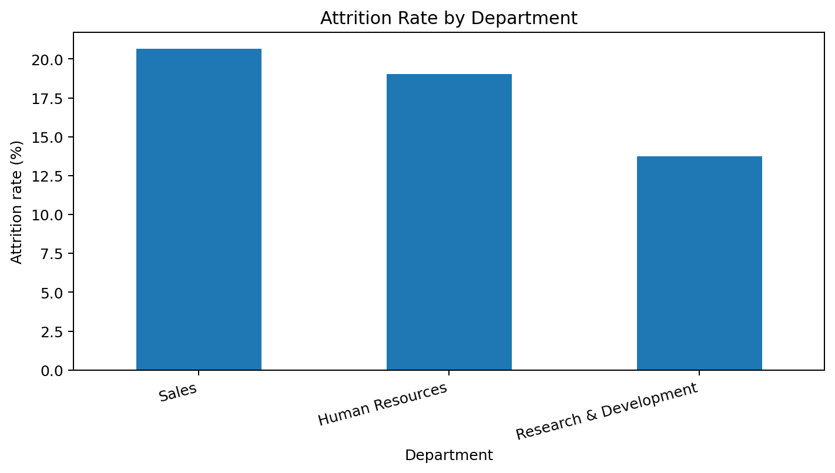
In this dataset, Sales has the highest department-level rate at 20.67%. The lowest-rate department is Research & Development at 13.75%. Differences should be reviewed alongside group size, role mix, workload and management context.
Suggested follow-up: review team-level workload, staffing, career pathways, manager support and employee feedback. Avoid treating a department's rate as proof that every employee in that department is dissatisfied.

16. Job Role Analysis
Job-role analysis is useful because different roles may have different schedules, customer demands, training requirements and career pathways. A rate comparison can identify roles for further study, but it should be paired with counts and contextual information.
JobRole | Attrition Yes | Group Records | Attrition Rate
Sales Representative | 33 | 84 | 39.29%
Laboratory Technician | 62 | 261 | 23.75%
Human Resources | 12 | 52 | 23.08%
Sales Executive | 58 | 329 | 17.63%
Research Scientist | 47 | 293 | 16.04%
Healthcare Representative | 9 | 132 | 6.82%
Manufacturing Director | 10 | 147 | 6.80%
Manager | 5 | 102 | 4.90%
Research Director | 2 | 80 | 2.50%

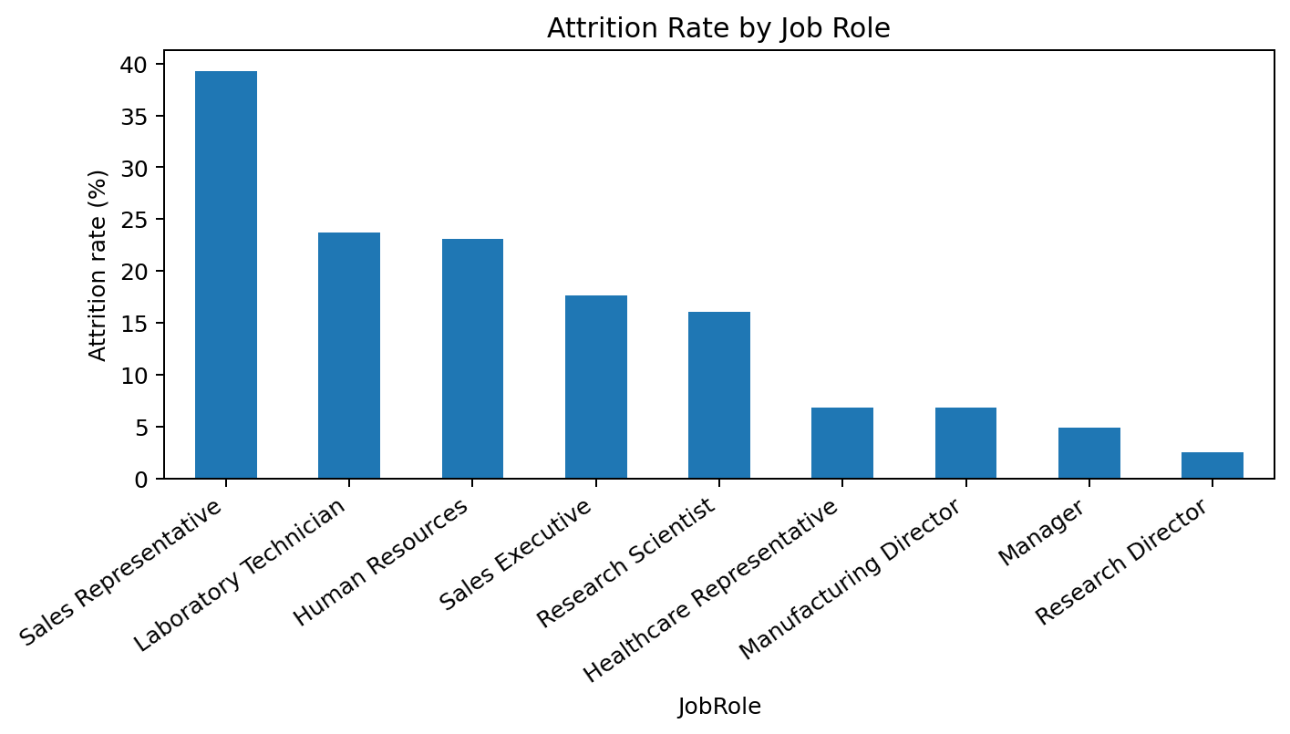
The highest observed job-role rate is for Sales Representative at 39.29%. This finding should be treated as a signal for further investigation rather than a conclusion about the role itself.
Suggested follow-up: examine role expectations, onboarding, training, workload, pay bands, promotion opportunities and exit feedback. Small groups can produce volatile percentages, so include the number of records in each role when presenting findings.

17. Overtime Analysis
Overtime analysis compares the attrition rate among records marked OverTime = Yes and OverTime = No. It is important to calculate the rate within each overtime group rather than comparing only the number of Yes records.
OverTime | Attrition Yes | Group Records | Attrition Rate
Yes | 128 | 418 | 30.62%
No | 110 | 1062 | 10.36%

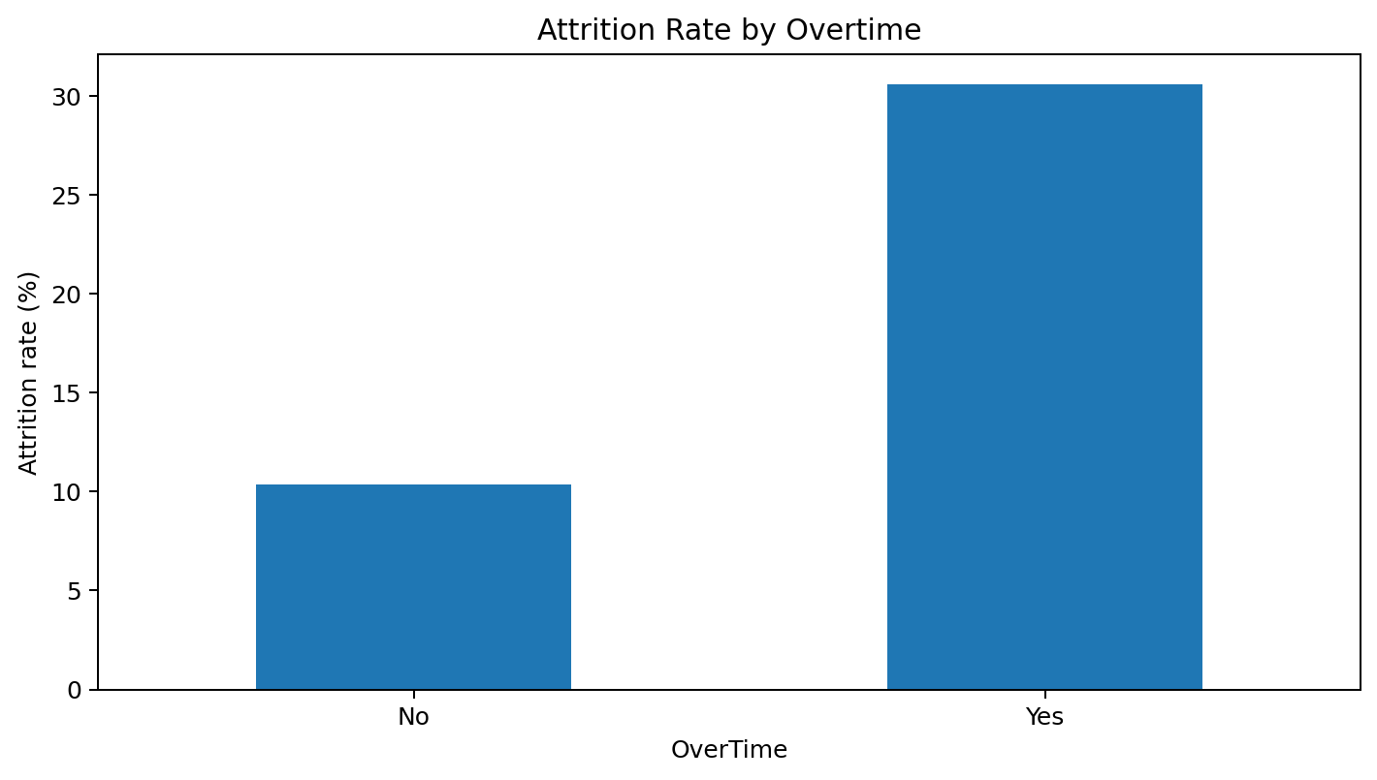
The observed rate is 30.62% for OverTime = Yes and 10.36% for OverTime = No. The difference is 20.26 percentage points.
Possible follow-up questions include whether overtime is frequent, predictable, fairly distributed and supported by appropriate staffing. The dataset does not prove that overtime causes attrition; role, level, manager practices and other factors may be related to both.

18. Age Group Analysis
Age-group analysis compares recorded rates across the age bands available in the dataset. Age is a personal characteristic, so findings should be used to improve general support and understand workforce patterns, not to stereotype or make individual employment decisions.
AgeGroup | Attrition Yes | Group Records | Attrition Rate
18-25 | 44 | 123 | 35.77%
26-35 | 116 | 611 | 18.99%
55+ | 8 | 47 | 17.02%
46-55 | 27 | 228 | 11.84%
36-45 | 43 | 471 | 9.13%

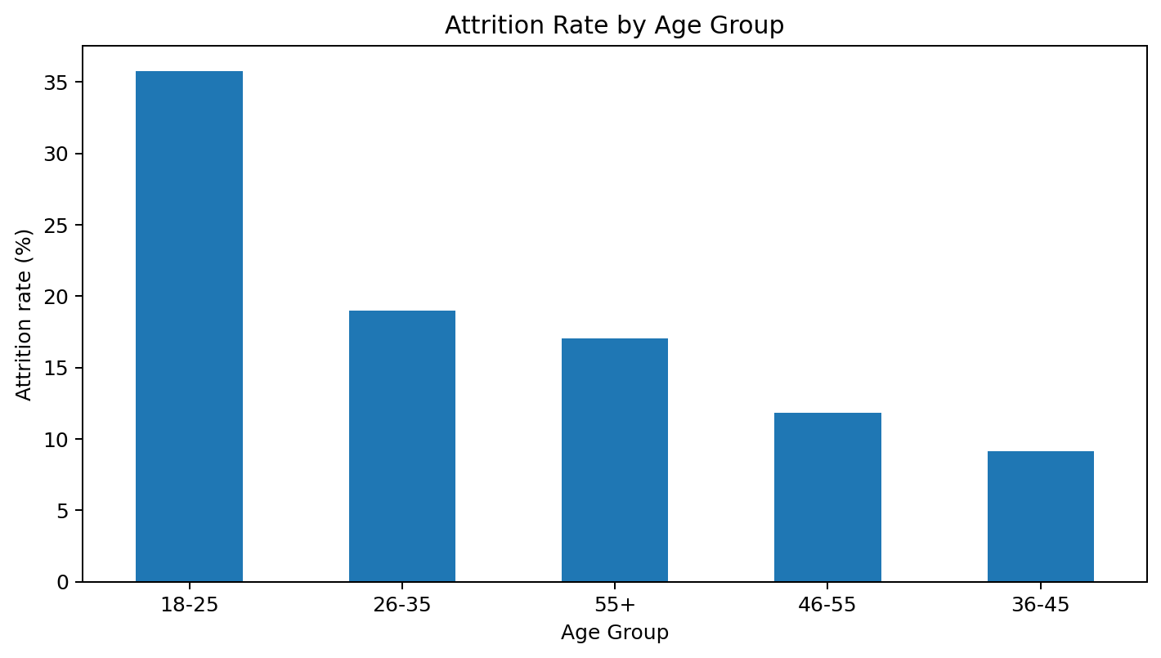
The highest observed rate is in the 18-25 group at 35.77%. Possible areas to investigate include onboarding, early-career development, training, job expectations and progression opportunities.
This analysis cannot tell us why a person left. Age groups may also differ in tenure, salary, job level or family circumstances, which are not disentangled by a simple descriptive comparison.

19. Salary Slab Analysis
Salary-slab analysis compares attrition rates across the salary bands included in the dataset. Compensation can be relevant to retention, but salary is often linked to job level, tenure, skill requirements and promotion history.
SalarySlab | Attrition Yes | Group Records | Attrition Rate
Upto 5k | 163 | 753 | 21.65%
10k-15k | 21 | 150 | 14.00%
5k-10k | 49 | 444 | 11.04%
15k+ | 5 | 133 | 3.76%

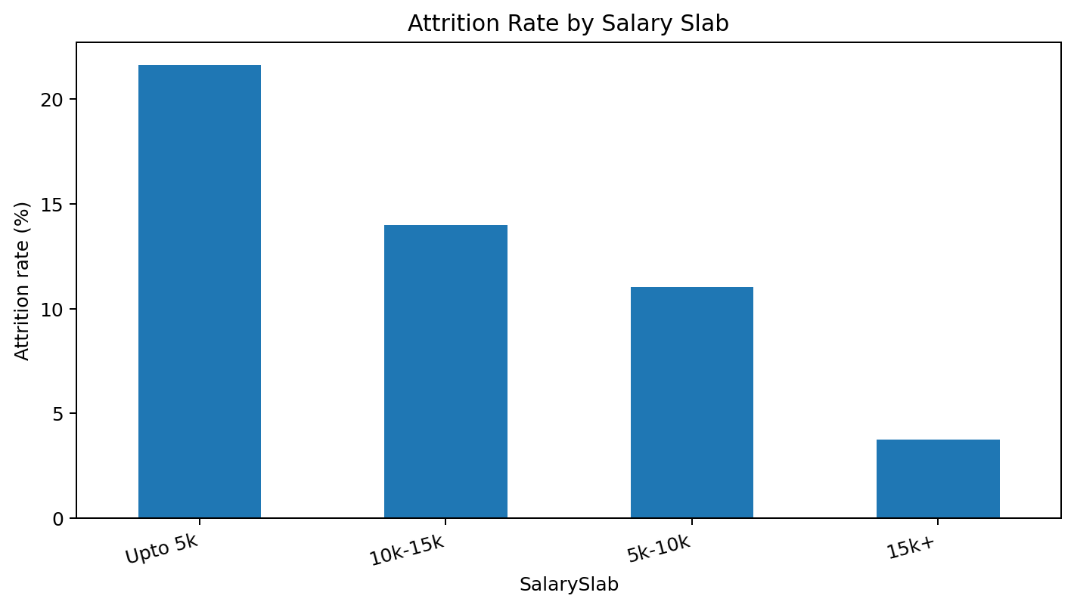
The highest observed salary-slab rate is Upto 5k at 21.65%. This does not demonstrate that pay alone explains attrition.
Suggested follow-up: review internal pay equity, market competitiveness, promotion transparency and whether compensation matches job responsibilities. Such a review should use appropriate job-level comparisons and lawful, fair procedures.

20. Marital Status Analysis
The supplied data includes a marital-status category. The report includes a descriptive comparison only to answer the task's analytical question. Marital status is sensitive personal information and should not be used to stereotype employees or determine hiring, promotion, scheduling or retention decisions.
MaritalStatus | Attrition Yes | Group Records | Attrition Rate
Single | 120 | 473 | 25.37%
Married | 84 | 679 | 12.37%
Divorced | 34 | 328 | 10.37%

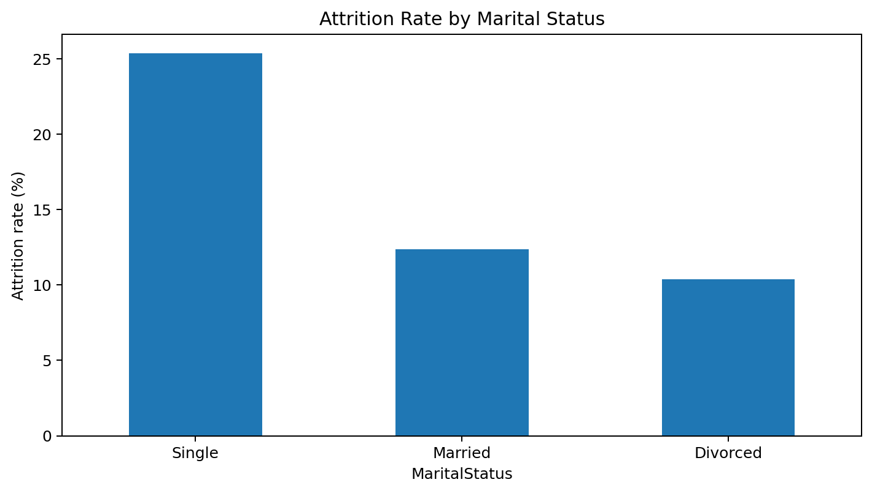
Any differences may reflect other factors, such as age, tenure, role or schedule. A simple group comparison cannot identify the explanation. The appropriate use is limited to understanding aggregate patterns with privacy safeguards and a clear business purpose.

21. Business Travel Analysis

21. Business Travel Analysis
BusinessTravel | Attrition Yes | Group Records | Attrition Rate
Travel_Frequently | 69 | 279 | 24.73%
Travel_Rarely | 157 | 1050 | 14.95%
Non-Travel | 12 | 151 | 7.95%

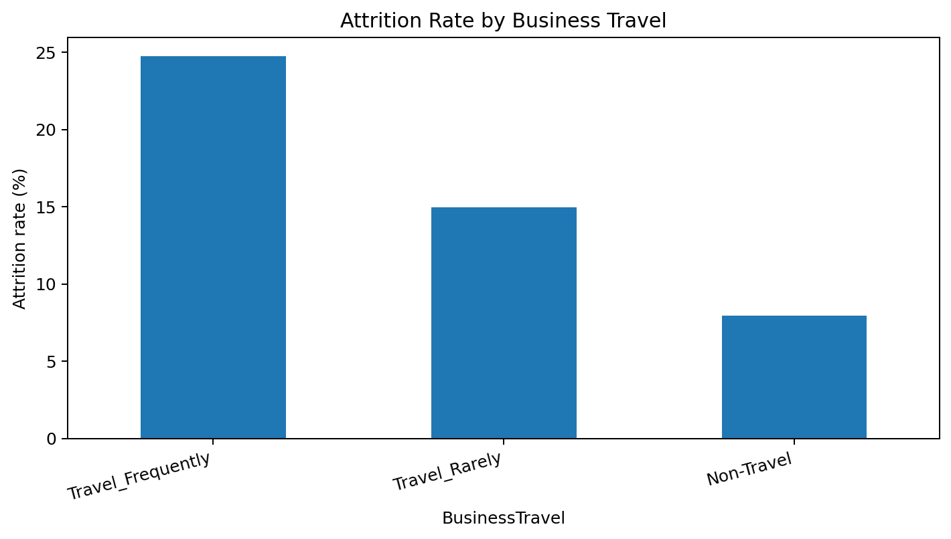
The highest observed travel-category rate is Travel_Frequently at 24.73%. This is a descriptive pattern. Before drawing conclusions, confirm that travel labels have been standardized correctly and consider differences in job role and travel demands.
A possible follow-up is to examine whether travel frequency, notice, recovery time and role expectations are associated with employee experience. The analysis should not assume travel itself is the cause.

22. Visualization and Interpretation
Charts make group comparisons easier to understand, but they can also mislead if axes, labels or denominators are unclear. Every chart in this report uses group-level attrition rate, expressed as a percentage.
- Use a descriptive title that states what is being compared.
- Label the y-axis as attrition rate (%) and show readable category names.
- Show group counts alongside rates when possible.
- Use the same definition of Attrition = Yes in every comparison.
- Do not interpret a bar chart as evidence of causation.
- Check category labels and ensure missing values are not silently treated as meaningful categories.
A bar chart is appropriate for comparing a numerical summary across categories. Future work could include confidence intervals, cross-tabulations or multivariable analysis if the dataset and learning objectives support those methods.

23. Key Findings
- The dataset contains 1480 employee records and 38 columns.
- 238 records are marked Attrition = Yes, giving an overall rate of 16.08%.
- Group-level attrition rates vary across the departments and job roles represented in the file.
- Overtime status shows a notable difference in observed attrition rates in the supplied data.
- Age and salary groups also show different recorded rates.
- Marital-status differences are descriptive only and require special care because the field is sensitive.
- Missing values, duplicate rows and inconsistent category labels need review before official decision-making.

- Results should guide questions for further investigation, not be used as standalone explanations or individual-level decisions.

24. HR Recommendations

Review workload and overtime
Audit overtime hours, staffing levels, scheduling predictability and recovery time. Discuss whether overtime is voluntary and distributed fairly.

Improve role-specific support
Review onboarding, training, role clarity, manager support and progression pathways for roles with higher observed rates.

Strengthen early-career development
Consider structured onboarding, mentoring, training plans and regular check-ins for newer employees, based on workforce needs rather than assumptions about age.

Review compensation transparently
Use job-level and market comparisons to assess whether pay structures are fair and competitive. Avoid assuming that a single salary band explains attrition.

Collect qualitative feedback
Use confidential, voluntary exit interviews and employee surveys to understand context that the CSV cannot capture.

Improve data governance
Document definitions, measurement periods, source, update frequency, access permissions and quality checks.

Monitor trends over time
Track rates by period and compare before and after changes, while accounting for changes in workforce composition.

Use fair and privacy-aware practices
Report aggregate results, limit access to personal data and avoid decisions based on sensitive characteristics.

25. Fairness, Privacy and Ethics
Employee data can be sensitive. A responsible analyst should only use data for a legitimate purpose, protect it from unauthorized access, and avoid exposing employee-level records in a public repository. Group-level analysis is generally more appropriate for a portfolio report than publishing identifiable employee details.
- Do not upload personal or confidential employee data to a public GitHub repository without explicit permission.
- Remove direct identifiers if they are not needed for the learning task.
- Do not use marital status, age or other sensitive characteristics to make individual employment decisions.
- Check whether small groups could make an individual identifiable from reported statistics.
- Explain uncertainty and limitations rather than presenting percentages as universal facts.
- Use findings to investigate systems and working conditions, not to blame a group of employees.

26. Limitations
. The source, sampling method and time period are not established by the CSV file alone.
. The analysis is descriptive and does not establish causal relationships.
. Group-level percentages can be unstable when a group has few records.
. Several factors may be related to one another; for example, role, pay, tenure and overtime may overlap.
. Missing values and duplicate rows require review and may affect analyses involving affected records.
. Attrition may have a specific definition in the dataset that should be confirmed with its provider.
. patterns do not necessarily describe current employee conditions.
. Results should not be generalized to every company or workforce without validation.

27. Testing and Validation
A project should be checked before submission. The following tests help ensure that code and report are consistent.
- Confirm that the CSV filename and path match the file on the laptop.
- Run every notebook cell from top to bottom after restarting the kernel.
- Check that the displayed row and column counts match the source file.
- Verify that Attrition values are limited to expected categories or document unexpected values.
- Check the overall rate manually using Yes count divided by total records.
- Confirm that each group rate uses the group's own total as the denominator.
- Check chart titles, axis labels and category names.
- Ensure report results match final notebook outputs.
- Save the notebook with outputs and keep a backup of the original CSV.
- Do not publish the dataset publicly unless sharing is allowed.

28. Learning Outcomes
By completing this project, a beginner can demonstrate the following skills:
- Reading a CSV file into Pandas.
- Understanding rows, columns and data types.
- Checking missing values and duplicate records.
- Inspecting categorical fields and standardizing confirmed label variations.
- Calculating totals, counts and percentage rates.
- Grouping data by department, role and other categories.
- Creating bar charts with Matplotlib and Seaborn.
- Interpreting descriptive results carefully.
- Writing a structured analytical report.
- Organizing project files for a portfolio and GitHub repository.
These are foundational skills for further study in data analytics, business intelligence and introductory machine learning. Present the work as a learning project unless it has been independently validated in a professional setting.

29. Conclusion and Future Scope
This project applied a structured data science workflow to the supplied HR dataset of 1,480 records and 38 columns. The overall recorded attrition rate was 16.08%. The group comparisons showed that recorded attrition rates differ across overtime status, departments, job roles, age groups, salary slabs and marital-status categories. These patterns can help identify areas for further investigation, but they do not establish why any employee left.
The project demonstrates the role of Python, Pandas, NumPy, Matplotlib and Seaborn in moving from a raw CSV file to summaries, charts and written findings. It also demonstrates that data quality, careful denominator selection, privacy and fair interpretation are essential parts of responsible analytics.
Future work could add time-based analysis if dates are available, examine relationships between tenure and attrition, include confidence intervals for group rates, or build a carefully validated model for educational purposes. Any predictive model would require an appropriate target definition, train/test separation, fairness checks and restrictions against using predictions as the sole basis for employment decisions.

30. Appendix A — Reproducible Analysis Code
The following consolidated example can be run in a Jupyter Notebook. Keep the CSV in the notebook folder or update the path. Run cells in order.
# Cell 1: Imports and load
import pandas as pd
import numpy as np
import matplotlib.pyplot as plt
import seaborn as sns
df = pd.read_csv("HR_Analytics(1).csv")
print("Shape:", df.shape)
display(df.head())
# Cell 2: Basic quality checks
print("Missing values:")
print(df.isna().sum().sort_values(ascending=False).head(10))
print("Exact duplicate rows:", df.duplicated().sum())
print(df["Attrition"].value_counts(dropna=False))
# Cell 3: Overall rate
attrition_yes = df["Attrition"].astype(str).str.strip().str.lower().eq("yes").sum()
overall_rate = attrition_yes / len(df) * 100
print(f"Overall attrition rate: {overall_rate:.2f}%")
# Cell 4: Reusable group rate function
def attrition_rate_by(group_col):
temp = df.copy()
temp["Attrition"] = temp["Attrition"].astype(str).str.strip().str.lower()
return (
temp.groupby(group_col)["Attrition"]
.apply(lambda x: x.eq("yes").mean() * 100)
.sort_values(ascending=False)
.round(2)
)
for column in ["Department", "JobRole", "OverTime", "AgeGroup", "SalarySlab", "MaritalStatus"]:
print("\\n", column)
print(attrition_rate_by(column))
# Cell 5: Example visualization
temp = df.copy()
temp["Attrition"] = temp["Attrition"].astype(str).str.strip().str.lower()
rates = temp.groupby("OverTime")["Attrition"].apply(lambda x: x.eq("yes").mean() * 100)
rates.plot(kind="bar")
plt.title("Attrition Rate by Overtime")
plt.xlabel("OverTime")
plt.ylabel("Attrition rate (%)")
plt.tight_layout()
plt.show()
Run this code in the same environment as the CSV. If your local filename differs, update read_csv(). Check the actual category labels in the output and make sure all charts reflect the final cleaned data.

31. Appendix B — Suggested GitHub Portfolio Structure
hr-analytics-attrition-analysis/
|-- HR_Analytics_Attrition_Analysis.ipynb
|-- HR_Analytics_Long_Detailed_Report.docx
|-- README.md
|-- charts/
|-- department.png
|-- overtime.png
|-- jobrole.png
|-- agegroup.png
|-- salary.png
|-- marital.png
|-- travel.png
Do not add the raw HR dataset to a public repository unless you have permission to share it. If it cannot be shared, explain in README that the data was supplied privately and is intentionally excluded.

README should contain
- Project title and short summary.
- Objectives and questions answered.
- Tools and library names.
- Instructions for opening and running the notebook.
- Key findings with careful language.
- Known limitations and data-quality notes.
- Data source and permission statement, if available.

32. References
- Pandas documentation — https://pandas.pydata.org/docs/
- NumPy documentation — https://numpy.org/doc/
- Matplotlib documentation — https://matplotlib.org/stable/
- Seaborn documentation — https://seaborn.pydata.org/
- Jupyter documentation — https://docs.jupyter.org/
- Dataset: HR_Analytics(1).csv supplied for this project. The original source and sharing permissions should be confirmed separately.

